Asociación Profesional de Prácticos  de Puertos del Río Paraná  (Professional Chamber of  Paraná River Harbour Pilots)  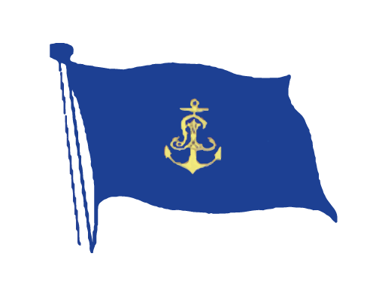  The master and the pilot should exchange information regarding navigational procedures, local conditions and rules and the ship’s characteristics.  We want to ensure that essential exchange items are covered.  This card is a supplement and assist, not substitute for, the verbal information exchange. | PILOT INFORMATION CARD (“MPX Card”)  Please provide me with the following:  1 Vessel deficiencies. Inform about any system, which is not working properly.  2 Pilot information Card.  3 Draft fore and aft.  4 Air draft, corrected for trim.  5 Location of navigation equipment.  6 Type of propulsion. Restricted number of air starts of Main Engine, Propeller type and rotation sense.  7 Engine notice requirements.  8 Thruster status/horsepower, if equipped.  9 Maneuvering speed..  10 Known errors in the gyrocompass.  11 Any deficiencies or unusual characteristics of the navigation or ship control systems.  12 Necessary notice for crew call-out.  13. Crew limitations.  Remarks of above items  Please set up the ship´s equipment in the following manner:  VHF Radios: Ch. 09, 12, 14 and working channels. Pilot Ladder: Check current Pilot’s requirements  Prior to pilot transfer, please ensure that the ladder is properly rigged, manned, and well lit at night.  For berthing, arrange 100 mts line on deck for each mooring winch. Propeller has to be submerged (Draft recommended: aft 3% of LOA, forward 2% of LOA) Anchors ready to use in case of an emergency. | RECOMMENDATIONS FOR PORTS  (Please tick boxes as acknowledged)  For further information please go to http://pilots.com.ar  Or https://rosariopilots.com  ARROYO SECO  Berths Dreyfus Cereal, Oil, and ADM, it is recommended the use of 1 tug.  Remark:  SAN NICOLAS  For vessels more than 178 mts LOA or more than 8,50 mts draft or in case of unfavorable hydrometeorogical conditions. It is recommended the use of 1 tug.  Remarks:  RAMALLO  For berthing at Bunge Fertilizer terminal is recommended the use of 1 tug.  Remarks:  SAN PEDRO  Maneuvering area is very limited; the channel is narrow and has curves. In addition, the surroundings areas do not have any illumination. For that reason, we strongly advise that is crucial to carry out the maneuverings during the light time.  ALL PORTS OF PARANA RIVER  For turning without tug assistance, pilot may requiere maximum  rpm astern/ahead and quick response of Main Engine. In case of any engine restrictions like onboard computer based programme to control Main Engine speed or if the ship has installed an EPL or ShaPoLi solution to comply with EEXI requirements.it is recommended the use of 1 tug.  Remarks:  VESSEL SAFETY IS PARAMOUNT  MASTER ACKNOWLEDGE OF READ AND UNDERSTAND  THIS CARD PAGE NUMBER 1, 2 AND 3

